# A Mid-term Minor Project Report on

File Management System

Submitted in Partial Fulfillment of the Requirements for

Degree of **Bachelor of Engineering in Information Technology**

under Pokhara University

Submitted by:

**Anit Chaudhary, 12402**

**Bipin Subedi, 12411**

**Suresh Pokhrel, 12448**

Under the Supervision of:

**Mr. Niranjan Khakurel**

Date:

9th April, 2016

 **Department of Information Technology**

**NEPAL COLLEGE OF**

**INFORMATION TECHNOLOGY**

Balkumari, Lalitpur, Nepal

# Abstract

*File Management System(FMS) is web-based application for the systematic handling of the files in the organization to organize the files recorded in database. FMS ensures the security violation with use of certified login. Simply, it is intended find intended files uploaded in the database just sitting by the chair. FMS introduces chat for the users within organization for chatting with the co-workers. File Dash board is for every users in the organization. Privilege for every user is set different to read, modify and delete.*

**Keywords**

*Employee Organization FMS Projects System*

**List OfAbbreviation**

FMS : File Management System

GUI : Graphical User Interfaces

Contents

Abstract i

1. Introduction 1

1.1. Problem Statement 2

1.2. Significance Of Study 3

1.3. Project Objectives 4

2. Scope 5

3. Project Development Cycle 6

4. Performance analysis methodology 8

5. Analysis And Design phase 9

5.1. Architectural Skeleton: 9

5.1.1. Presentation tier: 9

5.1.2. Application and Logical Tier: 9

5.1.3. Data Tier: 9

6. Requirement 10

6.1. Functional Requirement: 10

6.2. Non Functional Requirement: 10

7. Teams and Tools 11

7.1. Teams 11

7.2. Tools 11

8. System Design 12

8.1. E-R Diagram 12

8.2. UseCase Diagram 13

8.3. Dataflow Diagram 13

9. Time Schedule 14

10. Bibliography 15

**Lists Of tables:-**

Table 1:Functional requirements 10

Table 2:Non-Functional Requirements 10

Table 3: Team Division 11

Table 4: Tools Required 11

**Lists Of Figures**

Figure 1: Waterfall Model 6

Figure 2: 3-tier Architecture 9

Figure 3: Entity-Relationship Diagram 12

Figure 4: Use-Case Diagram 13

Figure 5:Data Flow Diagram 13

# Introduction

**File management**, formerly known as data management, is the upgraded version of the previously made desktop-based application as our mini project. It is intended to control the storing and accessing of data from web-browser. In our application, we use real time folder system as the reference to the database storage of any organization. FMS is java based web-application that focuses its usage within the organization. FMS come up search of files from database, chat with the clients. File Management System must store path of file, preserve the data inside the folder, maintain the hierarchy. Nonetheless, FMS also assists in deletion and insertion of the database contents according to the previledeges set by the application.

FMS, validated the multiple clients login with specific username and passwords from login frame.

## Problem Statement

Likely thousands of files increase in our organization, accessing these files is very tremendous waste of time for every time to search junk of files in shelf. Queuing Crowds of the people hour to hour in the offices has been common criteria to get work done. This made to come up with an idea that what if the file management is made digital rather handy works which will be beneficial for the client as well as employee. As we see files being lost, tore, misplace, theft and so on they should maintain the security in the storing of the files. Secure accessing of the database can provide the high security and provide effective management of the files.

## Significance Of Study

When the users practice well in such system in the computer, then they will find that working on our system with ease. However, the expertise level of stock management web application makes the user ease to deal with the stocks in market with effective information and good understanding of stocks. Since, it is the client side application that clients get notification as his/her organization’s stock has been downgraded or upgraded. The system provides Listing down from top to bottom with the rise and fall of stocks.

## Project Objectives

Main objectives of our project is to give easy layout for effective navigation to the files within the organization. FMS provides dashboard to each and every user of the FMS with some privilege. Secure browsing with login and privilege.Chatting with the co-workers inside the organization.

# Scope

Simple but efficient our project is seems to be less attractive, due to simple GUI having no any shadows, edge etc. has no any attractive stuffs embedded in it. Simple java platform is used to create our system. Only adding of files, sharing files among the employees. Additional feature we have got into is able to chat with each employee other can be seen our project. Multiuser can access through it.

Due to high competition market and our project seems to be very simple so there is less chance of being sold out. Now we are using local host for to run this project in our computer so business organization should owe its own host for it to run.

# Project Development Cycle

**Linear sequential method** is also called “Classic Life Cycle” or “Waterfall” model or “Software Life Cycle” suggests a systematic and sequential approach to software development that begins at the system level and progresses through analysis, design, coding, testing and support. The waterfall model derives its name due to the cascading effect from one phase. In this model each phase well defined starting and ending point, with identifiable deliveries to the next phase .

Analysis

Design

coding

Testing

Testing

Figure 1: Waterfall Model

**Analysis**

Firstly the concept was generated looking through mainly government offices. Queuing crews of the people hour to hour in the office made us to think once such system should be made.

**Design**

Making of this project is not completed yet. the project has been started so it takes time for the final design .Designing of webapp is going to be finished.

**Coding**

Coding has not been finished yet. But it is going along with the designing process.

**Testing**

White box testing will be performed in our project. We will be performing

* Unit testing

We will be testing every class in our project respectively one by one during our project.

* Integration testing

After we do unit testing, obviously we need to perform integration testing by integrating our each and every part of our system.

* Alpha testing

Alpha testing means to test the system in the developer’s side in the controlled environment. So we team will be testing the software by ourselves.

# Performance analysis methodology

* Our team will be working in the java web-based platform and coding in the ellipse.
* We will be trying using chatting system in our software.
* We will be using bootstrap for the responsive web application design.
* For the backend coding, we will be using spring framework, hibernate, JSP and for database, we will use MySQL.

# Analysis And Design phase

## Architectural Skeleton:

* Presentation tier
* Logical tier
* Data tier

### Presentation tier:

The GUI interface makes the user friendly environment for the interaction of the system. The login and logout through the GUI interface restrict the unauthorized user

### Application and Logical Tier:

The logical manipulation of the data accessed by the user like while login, while searching of files is evaluated over here. It is the bridge connection of both Tier. MVC architecture is followed in this architecture.

.

### Data Tier:

The data or files that needed to stored or taken out are stored in the database. Our application/logical tier may request information from the data tier, it then processes this information and returns it to the presentation tier in response to the user request

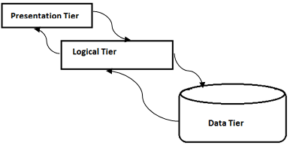

Figure 2: 3-tier Architecture

# Requirement

## Functional Requirement:

|  |  |
| --- | --- |
| **Requirements** | **Priority** |
| Users enables with login environment | Needed |
| Users can a upload of files | Needed |
| Users can chat with each other | Needed |
| Database stores the user’s data files as well as predefined data sets | Needed |
| System shows message notification | Needed |
| System shows as per their online status | Optional |

Table 1:Functional requirements

## Non Functional Requirement:

|  |  |
| --- | --- |
| **Requirements** | **Priority** |
| System works on Internet Browsers | Essential |
| The system is implemented using tools specified(Internet browser, Eclipse, E-draw, Project Libre,Xampp) | Essential |
| System must be user friendly | Essential |
| Runs on any operating system(windows,linux,and any other) | User’s desire |

Table 2:Non-Functional Requirements

# Teams and Tools

## Teams

Roles of each individual team members are given below:

|  |  |  |
| --- | --- | --- |
| **Titles** | **Name** | **Roles** |
| Developer and SQA | Anit Chaudhary | Developstheapplicationaccordingtoplan andspecificationproduced. |
| Desiging, Project Manager | Bipin Subedi | Designing ,Manage overall project ,indentify threads and risk occurring in entire system development |
| Documenting,Testing | Suresh Pokherel | Developstest plan, test cases and evaluatesoastocheck whether implementation satisfies therequirementperfectly ornot. |

Table 3: Team Division

## Tools

Tools Required For the Development of this Applications are

|  |  |
| --- | --- |
| **Tools** | **Purpose** |
| Browser(Mozilla firefox , internet explorer etc.) | Browsing |
| Eclipse | Coding |
| Project libre | Time schedule |
| My-Sql | Database design |
| Edraw Max 7.9 | Design |

Table 4: Tools Required

# System Design

## E-R Diagram

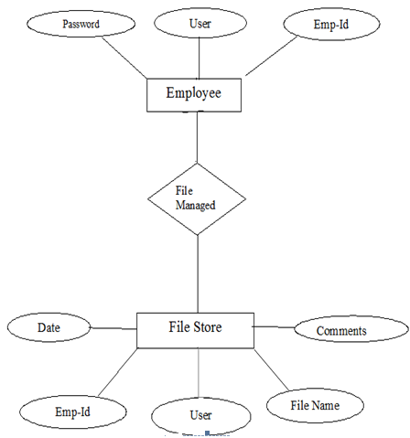

Figure 3: Entity-Relationship Diagram

## UseCase Diagram

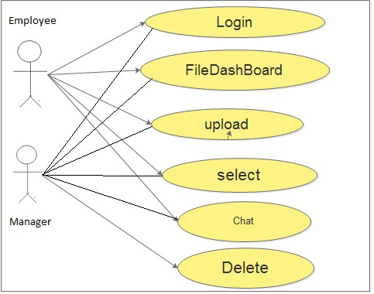

Figure 4: Use-Case Diagram

## Dataflow Diagram

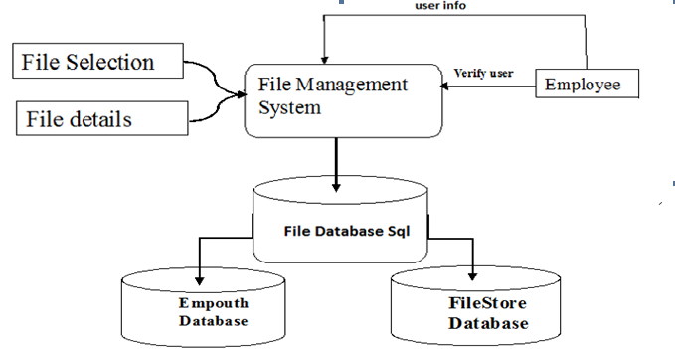

Figure 5:Data Flow Diagram

# Time Schedule

# 

# Bibliography

[1] Software Engineering Fundamentals, Robert S Pressman

[2] W3 School, Web: http://www.w3schools.com/accessed at: 3th April 2016

[3] “The Aptech Advanced Series”, Publication: November 2000

[4]Spring Framework ,Web:http://www.tutorialspoint.com/spring/ accessed at: 4th April 2016

[5]Hibernate, Web: http://www.tutorialspoint.com/hibernate/ accessed at: 2th April, 2016

[6]Code Pen, Web:http://www.codepen.io/ accessed at: 10th April, 2016

